

Lab 11: Create a VM with the CLI

At the end of each lab, any resources you created in your account will be preserved. Some Azure resources, such as VM instances, may be automatically shut down, while other resources, such as storage services will be left running. Keep in mind that some Azure features cannot be stopped and can still incur charges (i.e. Azure Bastion). To minimize your costs, delete all resources and recreate them as needed to test your work during a session.

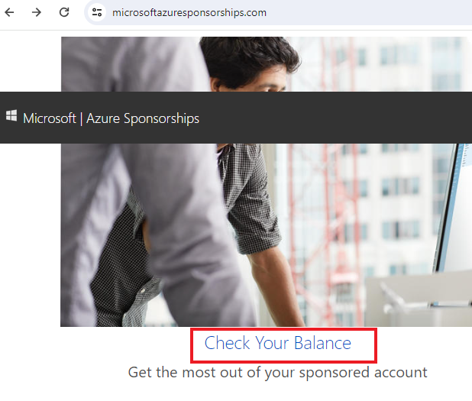

Reference: [AZ-900T0X-MICROSOFTAZUREFUNDAMENTALS](https://microsoftlearning.github.io/AZ-900T0x-MicrosoftAzureFundamentals)

# 11 - Create a VM with the CLI

In this walk-through, we will configure the Cloud Shell, use Azure CLI to create a resource group and virtual machine, and review Azure Advisor recommendations.

# Task 1: Configure the Cloud Shell (10 min)

In this task, we will configure Cloud Shell.

1. Sign in to the [Azure portal](https://portal.azure.com/) with your **odl_user_xxx** azure account
2. From the Azure portal, open the **Azure Cloud Shell** by clicking on the icon in the top right of the Azure Portal.

[Screenshot of Azure Portal Azure Cloud Shell icon.](https://microsoftlearning.github.io/AZ-900T0x-MicrosoftAzureFundamentals/Instructions/images/1002.png)

1. If you have previously used the Cloud Shell, proceed to the next task.
2. When prompted to select either **Bash** or **PowerShell**, select **Bash**.
3. When prompted, click **Create storage**, and wait for the Azure Cloud Shell to initialize.

# Task 2: Create a resource group and a virtual machine

In this task, we will use Azure CLI to create a resource group and a virtual machine.

1. Ensure **Bash** is selected in the upper-left drop-down menu of the Cloud Shell pane (and if not, select it).

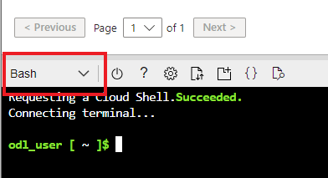

1. In the Bash session, within the Cloud Shell pane, create a new resource group.

CodeCopy

az group create --name myRGCLI --location EastUS

1. Verify the resource group was created.

CodeCopy

az group list --output table

1. Create a new virtual machine. Make sure that each line except for the last one is followed by the backslash (\) character. If you type the whole command on the same line, do not use any backslash characters.

CodeCopy

az vm create --name <studentID>VMCLI --resource-group myRGCLI --image Ubuntu2204 --location EastUS --admin-username azureuser --admin-password Pa$$w0rd1234 --storage-sku Standard_LRS --size Standard_B2s

**Note: Replace <studentID>VMCLI** withyour student ID (for example: **smore1VMCLI**)

**Note**: The command will take 2 to 3 minutes to complete. The command will create a virtual machine and various resources associated with it such as storage, networking and security resources. Do not continue to the next step until the virtual machine deployment is complete.

1. When the command finishes running, in the browser window, close the Cloud Shell pane.
2. In the Azure portal, search for **Virtual machines** and verify that **<studentID>VMCLI** is running.

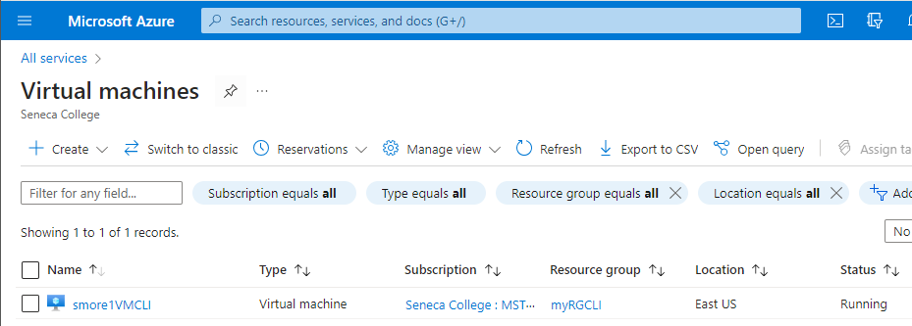

# Task 3: Execute commmands in the Cloud Shell

In this task, we will practice executing CLI commands from the Cloud Shell.

1. From the Azure portal, open the **Azure Cloud Shell** by clicking on the icon in the top right of the Azure Portal.
2. Ensure **Bash** is selected in the upper-left drop-down menu of the Cloud Shell pane.
3. Retrieve information about the virtual machine you provisioned, including name, resource group, location, and status. Notice the PowerState is **running**.
4. **Note: Replace <studentID>VMCLI** withyour student ID (for example: **smore1VMCLI**)

CodeCopy

az vm show --resource-group myRGCLI --name **<studentID>VMCLI**  --show-details --output table

1. Stop the virtual machine. Notice the message that billing continues until the virtual machine is deallocated.

CodeCopy

az vm stop --resource-group myRGCLI --name **<studentID>VMCLI**

1. Verify your virtual machine status. The PowerState should now be **stopped**.

CodeCopy

az vm show --resource-group myRGCLI --name **<studentID>VMCLI**  --show-details --output table

# Task 4: Review Azure Advisor Recommendations

In this task, we will review Azure Advisor recommendations.

**Note:** If you have completed the previous lab (Create a VM with PowerShell), then you have already performed this task.

1. From the **All services** blade, search for and select **Advisor**.
2. On the **Advisor** blade, select **Overview**. Notice recommendations are grouped by High Availability, Security, Performance, and Cost.

[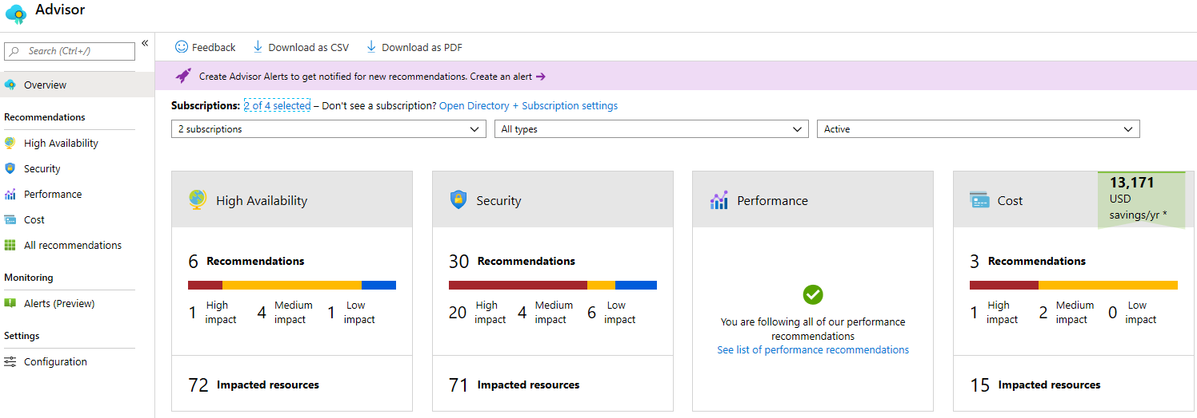](https://microsoftlearning.github.io/AZ-900T0x-MicrosoftAzureFundamentals/Instructions/images/1103.png)

1. Select **All recommendations** and take time to view each recommendation and suggested actions.

**Note:** Depending on your resources, your recommendations will be different.

[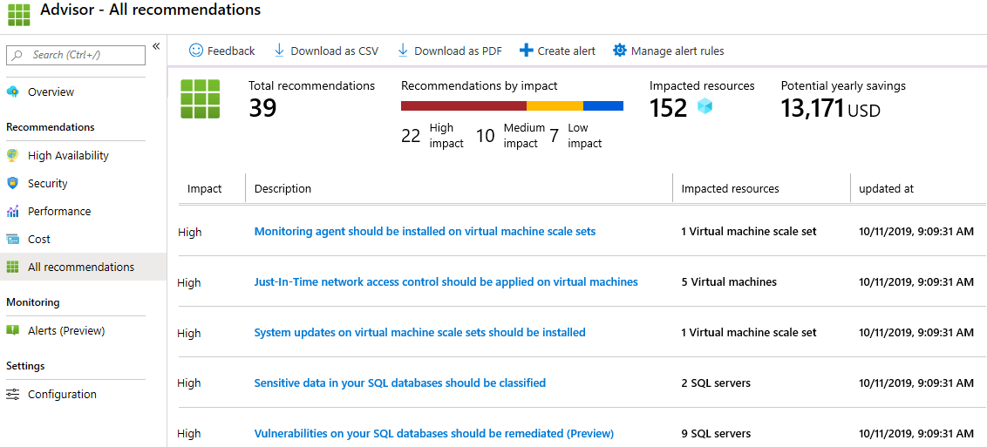](https://microsoftlearning.github.io/AZ-900T0x-MicrosoftAzureFundamentals/Instructions/images/1104.png)

1. Notice that you can download the recommendations as a CSV or PDF file.
2. Notice that you can create alerts.
3. If you have time, continue to experiment with Azure CLI.

Congratulations! You have configured Cloud Shell, created a virtual machine using Azure CLI, practiced with Azure CLI commands, and viewed Advisor recommendations.

**Note**: To avoid additional costs, you can remove all resources in the resource group. Search for resource groups, click your resource group, and then delete the resources within the resource group. **DO NOT DELETE YOUR RESOURCE GROUP.**

# Submission Requirements

Submit a screenshot with the following information:

**Screenshot #1:**

* Azure CLI and Portal listing of the vitual machine’s status as deallocated
* The Azure Portal with your **CloudLab Account** [requires another browser window]
  + **Note**: underline the above items as described in the below picture
* 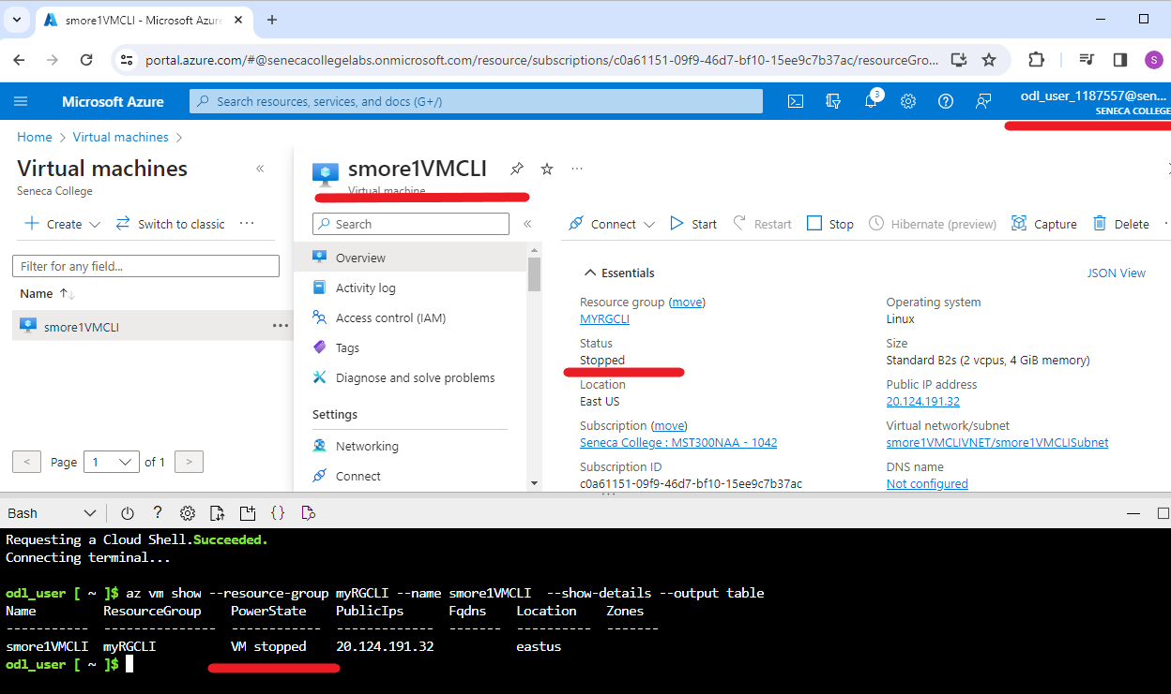

**Screenshot #2:**

* Successful deletion of all resources within resource group. **DO NOT DELETE YOUR RESOURCE GROUP!**
  + To delete all resources with a resource group, go to “**Resource Group**”, select “**MyRGCLI**”, select all resources within the resource group, and select “**Delete**”

